What is taking inventory and why is it important?
Taking inventory is a process that is used in almost every workplace. Examples include: parts in production for manufacturing and items on a shelf in a retail store. Each item is counted and recorded as part of an inventory process. Often a bar code or electronic tag are included in parts and that is scanned by a hand held device to identify the part. The quantity is counted and entered into the device.
The results of taking inventory can indicate that an action needs to be taken – such as purchasing more items when quantities are low, or replacing items that are broken or missing. In this case, it is important to take inventory of the items for the Boe-Bot so that parts that are missing or broken can be replaced. The parts for Boe-Bot do not have electronic ID tags, so a visual photo matching method is used for identification. Your honesty and accuracy are critical to this inventory process, so that all parts are available for you or for the next student.
Instructions:
- Read through this entire list so you know what to do before beginning the process.
- Separate out the small electronic parts and group items that are alike together. If the parts are new and in plastic bags, keep them with the bag.
- Pick up one component at a time, or one group of items. Count the quantity of that item.
- Identify the item using the photo IDs on the inventory sheet. That is the row you will use for the next two steps. (rows go across, columns go up and down)
- Write the count of item into the Your Count column next to the photo in the table.
- Look at the column labeled Storage Loc and find the number in the photos at the top of the sheet. Place the components into the storage location shown in the diagram.
- Repeat steps 3-7 for all items.
- When complete, there should be a number in the Your Count for every row of each table. If not, go back and double check to make sure you didn’t mistake one item for another and have too many items in one, but none in another.
- Compare the Inventory Qty number to Your Count number for every row in the table. If the numbers are different, copy the entire row and paste it into the table on the next page labeled Missing or Broken Parts Needed to Reorder.
- Print or send this sheet to your instructor via email (ask instructor).
Thank you for your assistance.
Box Label: _______ Your Name: __________________ Class:_________________ Date:___________
Storage Locations:
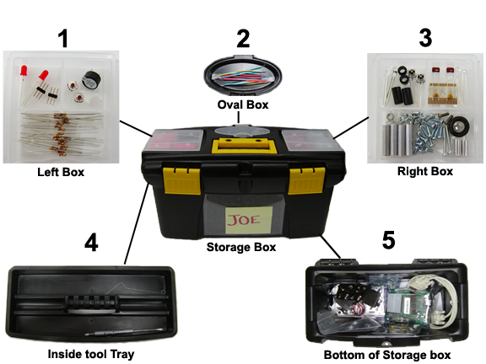

Mechanical Boe-Bot Hardware and Chassis Components:
# | Stock # | Part Name | Photo ID | Storage Loc | Inv. Qty | Your Count
 | 700-00064 | Parallax Screwdriver | 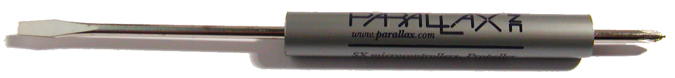 |  | 1
 | 900-00008 | Parallax Continuous Rotation Servo Motor | 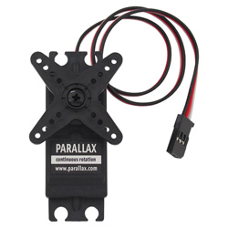 |  | 2
 | 700-00022 | Boe-Bot aluminum chassis | 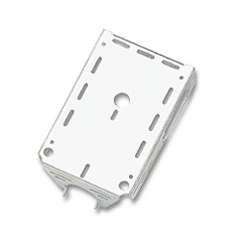 |  | 1
 | 700-00009 | Tail wheel ball | 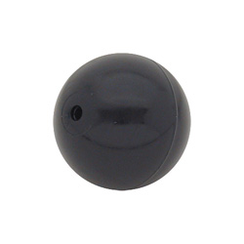 |  | 1
 | 700-00038 | Battery holder with cable and barrel plug | 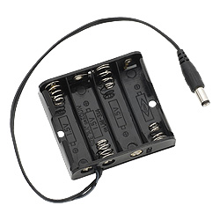 |  | 1
 | 721-00001 | Parallax plastic wheel | 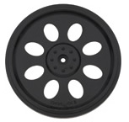 |  | 2
 | 721-00002 | Rubber band tire | 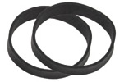 |  | 4
 | 700-00023 | Cotter pin, 1/16" x 1.5” long | 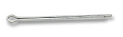 |  | 1
 | 700-00025 | Rubber grommet, 13/32" | 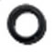 |  | 2
 | 700-00028 | Machine screw, 4-40 x 1/ 4” pan-head Phillips | 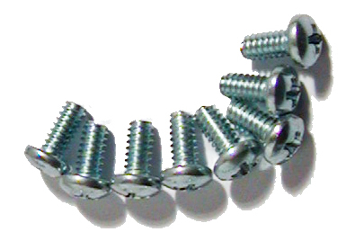 |  | 8
 | 700-00060 | Standoff, threaded aluminum, round 4-40 | 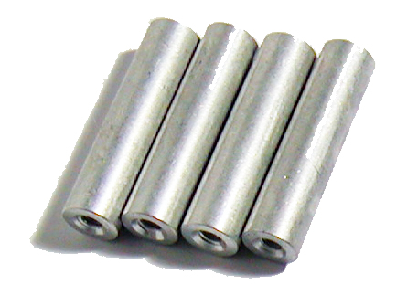 |  | 4
 | 710-00007 | Machine screw, 7/8” 4-40 pan-head, Phillips | 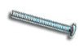 |  | 2
 | 713-00007 | 1/2” Spacer, aluminum, #4 round | 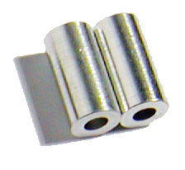 |  | 2
 | 700-00002 | Machine screw, 3/8” 4-40 pan-head, Phillips | 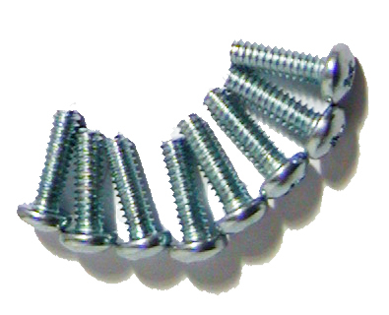 |  | 8
 | 700-00003 | Hex nut, 4-40 zinc plated | 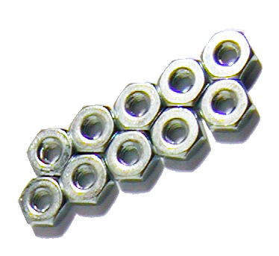 |  | 10
 | 700-00015 | Nylon washer, #4 screw-size | 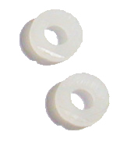 |  | 2
 | 700-00016 | Machine screw, 4-40 x 3/8” flathead | 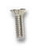 |  | 2

Circuit Board, Connections, and Brain Components:
# | Stock # | Part Name | Photo ID | Storage Loc | Inv. Qty | Your Count
 | BS2-IC | BASIC Stamp 2 microcontroller module | 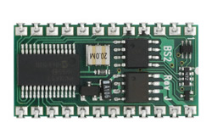 |  | 1
 | 28150 | Board of Education - Serial | 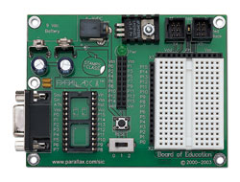 |  | 1
 | 800-00003 | Serial cable | 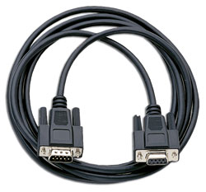 |  | 1
 | 28031 | USB to Serial Adapter and USB A to Mini B Cable | 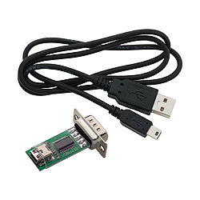 |  | 1

Electronic Parts Components
# | Stock # | Part Name | Photo ID | Storage Loc | Inv. Qty | Your Count
 | 150-01020 | 1 kΩ resistor (colors: Brown, Black, Red, Gold. ) | 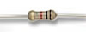 |  | 2
 | 150-01030 | 10 kΩ resistor (colors: Brown, Black, Orange, Gold. ) | 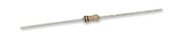 |  | 4
 | 150-02020 | 2 kΩ resistor (colors: Brown, Black, Yellow, Gold. ) | 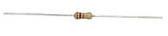 |  | 2
 | 150-02210 | 220 Ω resistor (colors: Red, Red, Brown, Gold. ) | 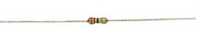 |  | 8
 | 150-04710 | 470 Ω resistor (colors: Yellow, Purple, Brown, Gold. ) | 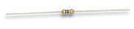 |  | 4
 | 150-04720 | 4.7 kΩ resistor (colors: Yellow, Purple, Brown, Gold. ) | 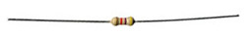 |  | 2
 | 200-01031 | 0.01 μF capacitor | 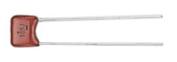 |  | 2
 | 200-01040 | 0.1 μF capacitor | 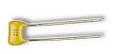 |  | 2
 | 350-00003 | Infrared LED | 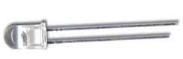 |  | 2
 | 350-00006 | Red LED | 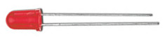 |  | 2
 | 350-00029 | Phototransistor | 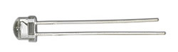 |  | 2
 | 350-00014 | Infrared receiver (Panasonic PNA4602M or equivalent) | 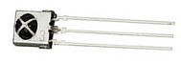 |  | 2
 | 350-90000 | LED standoff for infrared LED | 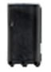 |  | 2
 | 350-90001 | LED light shield for infrared LED |  |  | 2
 | 400-00002 | Pushbutton, normally open | 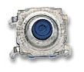 |  | 2
 | 451-00303 | 3-Pin Header | 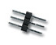 |  | 2
 | 700-00056 | Whisker wire | 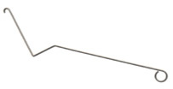 |  | 2
 | 800-00016 | Jumper wires (bag of 10) | 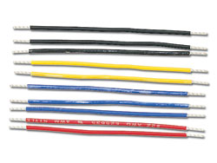 |  | 2
 | 900-00001 | Piezospeaker | 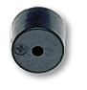 |  | 1

Box Label: _______ Your Name: __________________ Class:________________ Date:___________
Missing or Broken Parts Needed to Reorder:
# | Part Name | Photo | Storage Loc | Inv Qty | Your Count

